

GUIDELINES FOR PREPARATION OF M.E./M.TECH PHASE I REPORT

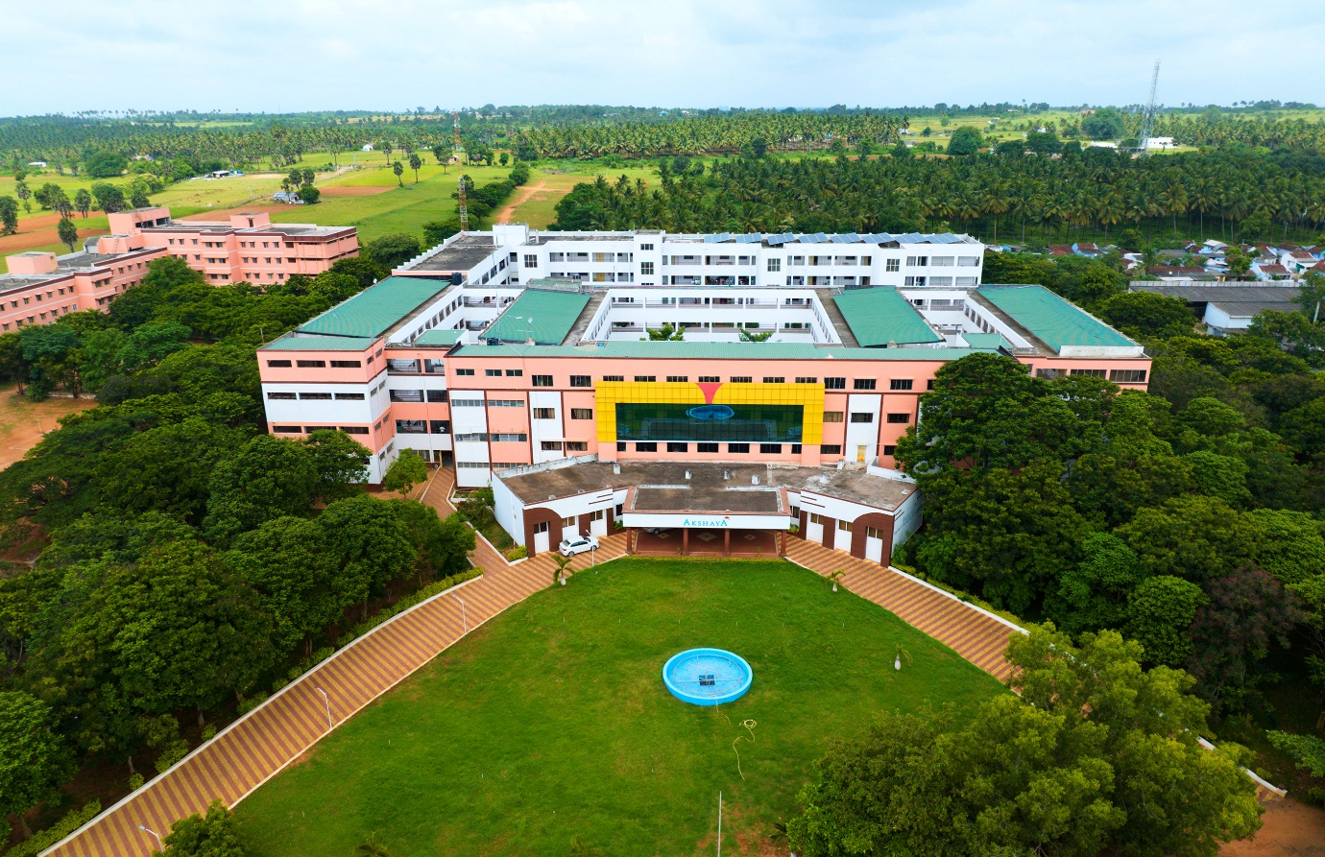

Prescribed Format and Specification

GENERAL:
The broad guidelines to the preparation of M.E./M.Tech report/ thesis are outlined below. In general, the thesis shall report, in an organized fashion, an account of original research work of the student leading to the discovery of new facts or techniques or correlation of facts already known (analytical, experimental, hardware oriented etc) and demonstrating a quality so as to make a definite contribution to the advancement of knowledge and the student's ability to undertake sustained research and present the findings in an appropriate manner with actual accomplishments of the work plainly stated and honestly appraised.

NUMBER OF COPIES TO BE SUBMITTED FOR EVALUATION:
M.E. / M.Tech Report /Thesis : Three copies are to be submitted to the
Department where the student is studying (one copy each to student, supervisor and Department library)

SIZE OF REPORT / THESIS:
The size of report should not be less than 25 pages for phase I and 40 pages for phase II thesis, (with more emphasis on results and discussions) of typed matter reckoned from the first page of Chapter 1 to the last page of the Appendix.

ARRANGEMENT OF CONTENTS OF REPORT /THESIS:
The sequence in which the report / thesis material should be arranged and bound should be as follows:
- Cover Page & Title page
- Bonafide Certificate
- Abstract (Tamil and English)
- Acknowledgement
- Table of Contents
- List of Tables
- List of Figures
- List of Symbols, Abbreviations and Nomenclature (Optional)
- Chapters
- Appendices
- References

The Tables and Figures shall be introduced in the appropriate places.

PAGE DIMENSIONS AND MARGIN:
The dimensions of the report/ thesis should be 290mm x 205mm. Standard A4 size (297mm x 210mm) paper may be used for preparing the copies.

The Report /Thesis (at the time of submission) should have the following page margins : Top edge : 30 to 35 mm
Bottom edge : 25 to 30 mm
Left side : 35 to 40 mm
Right side : 20 to 25 mm

The report/thesis should be prepared on good quality white paper preferably not lower than 80 gsm.

Tables and figures should conform to the margin specifications. Large size figures should be photographically or otherwise reduced to the appropriate size before insertion.

MANUSCRIPT PREPARATION:
The general text of thesis shall be typed in font style Times New Roman and font size 13. Same quality of paper should be used for the preparation of the entire report / thesis.

The headings of all items 2 to 10 listed in section 4 should be typed in capital letters without punctuation and centered 50mm below the top of the page. The text should commence 4 spaces below this heading.
  - Cover Page & Title Page - A specimen copy of the Cover page & Title page for report/thesis are given in Annexure I.

  - Bonafide Certificate – The Bonafide Certificate shall be in 1 ½ and double spacing as per the format shown in Annexure II. The certificate shall carry the supervisor’s signature and shall be followed by the supervisor’s name, academic designation (not any other responsibilities of administrative nature), department and full address of the institution where the supervisor has guided the student. If Joint Supervisor is involved, a third column may be added after the Supervisor with the details as similar to that of Supervisor.

  - Abstract - Abstract should be an essay type of narration not exceeding t wo pages outlining the research problem, the methodology used for tackling it and a summary of the findings, typed in double line spacing.
  - Acknowledgement – The acknowledgement shall be brief and should not exceed one page, typed in double spacing. The student’s signature shall be made at the right bottom above his / her name typed in capitals.

  - Table of contents - The table of contents should list all material following it as well as any material which precedes it. The title page, Bonafide Certificate and Acknowledgment will not find a place among the items listed in the Table of Contents but the page numbers in lower case Roman letters are to be accounted for them. One and a half spacing should be adopted for typing the matter under this head. A specimen copy of the Table of Contents for report / thesis is given in Annexure III.

  - List of Table - The list should use exactly the same captions as they appear above the tables in the text and the caption shall follow ‘sentence case’. One and a half spacing should be adopted for typing the matter under this head.

  - List of Figures - The list should use exactly the same captions as they appear below the figures in the text and the caption shall follow ‘sentence case’. One and a half spacing should be adopted for typing the matter under this head.

  - List of Symbols, Abbreviations and Nomenclature - One and a half spacing should be adopted for typing the matter under this head. Standard symbols, abbreviations etc. should be used.
  - Chapters - The chapters may include For Phase I – Report
Chapter I - Introduction Chapter II - Literature Review
Chapter III - Theoretical Background / Concepts/ Methodology /Design/ Modeling
The other chapters may include Project implementation / Results and Discussion as applicable.
Conclusions and Work schedule for Phase II Appendices (if any)
References (must also be included in text).
For Phase II Thesis
Chapter I - Introduction Chapter II - Literature Review
Chapter III - Theoretical Background / Concepts/ Methodology /Design/ Modeling
The other chapters may include Results of Analytical / Design / Modeling and Simulation / Experimental study and discussion as applicable.
Conclusions and Scope for future work Appendices (if any)
References (must also be included in text)
- The main text may have several chapters and each chapter may be divided into several divisions and sub-divisions.
- Each chapter should be given an appropriate title.

- Tables and Figures in a chapter should be placed in the immediate vicinity of the reference where they are cited.
- Footnotes should be used sparingly. They should be typed single space and placed directly underneath in the very same page, which refers to the material they annotate.

  - Appendices - Appendices are provided to give supplementary information, which if included in the main text may serve as a distraction and cloud the central theme under discussion.

    - Appendices should be numbered using Arabic numerals, e.g. Appendix 1, Appendix 2, etc.

    - Appendices, Tables and references appearing in Appendices should be numbered and referred to at appropriate places just as in the case of chapters.

    - Appendices shall carry the title of the work reported and the same title shall be made in the contents page also.

    - The list of publications made by research student during the period of research, shall be brought in the Appendix titled, as List of Publications and the same shall be reported in the contents. The author can refer the publications mentioned in the Appendix, in the text of the Report / Thesis, by mentioning his/her name followed by Appendix number and the year of publication, in brackets.

  - List of References - Any works of other researchers, if used either directly or indirectly, should be indicated at appropriate places in the report/thesis. The citation may assume any one of the following forms.

The authors publications during the period of research should not be included in the references and can be separately mentioned as in 6.10.

Examples of citation
- An improved algorithm has been adopted in literature (Tsychiya 1980)

- Jankins and Walts (1968) have dealt at length this principle.

- The problem of mechanical manupulators has been studied by Shin et al (1984) and certain limitations of the method used, has been pointed out by Shin et al (1984 a).
The listing should be typed 4 spaces below the heading "REFERENCES" in alphabetical order in single spacing left-justified. The reference material should be listed in the alphabetical order of the first author. The name of the author/authors should be immediately followed by the year and other details. A typical illustrative list given below relates to the citation example quoted above.

REFERENCES
  - Ariponnammal S. and Natarajan S. (1994), ‘Transport Phonomena of Sm Se1-x Asx’, Pramana – Journal of Physics, Vol. 42, No.5, pp.421-425.

  - Barnard R.W. and Kellogg C. (1980) ‘Applications of Convolution operators to Problems in univalent function theory’, Michigan Mach. Journal, Vol. 27, pp.1-94.

  - Jankins G.M. and Walts D.G. (1968),‘ Spectral Analysis and its Applications', Holder Day, Sanfrancisco.

  - Shin K.G. and Mckay N.D. (1984), ‘ Open loop minimum time control of mechanical manipulations and its applications’, Proc. Amer. Contr. Conf., San Diego, CA, pp.1231-1236.

  - Tables and Figures - By the word Table, is meant tabulated numerical data in the body of the thesis as well as in the appendices. All other non-verbal material used in the body of the thesis and appendices such as charts, graphs, maps, photographs and diagrams may be designated as figures.

    - A table or figure including caption should be accommodated within the prescribed margin limits and should appear on the page, where the first reference is made as far as possible.

    - Tables and figures on half page or less in length may appear on the same page along with the text. However, they should be separated from the text both above and below by triple spacing.

    - Two or more small tables or figures may be grouped if necessary in a single page.

    - Photographs if any, should be included as colour print only. More than one photograph can be included in a page.

    - Samples of Fabric, Leather, etc., if absolutely necessary may be attached evenly in a page and fixed/pasted suitably and should be placed in Appendix only.

The caption of figure should follow sentence case, centre aligned and placed below the figure. The caption of table should be at the top of the table, left aligned and placed above the table.

TYPING INSTRUCTIONS

General
This section includes additional information for final typing of the thesis. Some information given earlier under 'Manuscript preparation' shall also be referred. The impressions on the typed/duplicated/printed copies should be black in colour. Corrections, interlineations and crossing out of letters or words will not be permitted in any of the copies of the report/thesis intended for submission. Erasures, if made, should be neatly carried out in all copies. A sub-heading at the bottom of a page must have at least two full lines below it or else it should be carried over to the next page. The last word of any page should not be split using a hyphen. One and a half spacing should be used for typing the general text. The general text shall be typed in Font Style Times New Roman and Font Size 13.

Single spacing should be used for typing:

- Long Tables
- Long quotations
- Foot notes
- Multilane captions
- References

All quotations exceeding one line should be typed in an indented space, the indentation being 15mm from either margin. Double spacing should be used for typing the Bonafide Certificate and Acknowledgement.

Chapters

The format for typing chapter headings, division headings and sub division headings shall be same as given in Table of Contents.
The word CHAPTER without punctuation should be centred 50mm down from the top of the page. Two spaces below, the title of the chapter should be typed centrally in capital letters. The text should commence 4 spaces below this title, the first letter of the text starting 20mm, inside from the left hand margin.
The division and sub-division captions along with their numberings should be left-justified. The captions should start at 20 mm from left margin. The typed material directly below division or sub-division heading should commence 2 spaces below it and should be offset 20mm from the left hand margin. Within a division or sub-division paragraphs are permitted. The paragraph should commence 3 spaces below the last line of the preceding paragraph or caption, the first letter in the paragraph being offset from the left hand margin by 20 mm.

NUMBERING INSTRUCTIONS

Page Numbering
All pages numbers (whether it be in Roman or Arabic numbers) should be typed without punctuation on the upper right hand corner 20mm from top with the last digit in line with the right hand margin. The preliminary pages of the thesis (such as Title page, Acknowledgement, Table of Contents etc.) should be numbered in lower case Roman numerals. The title page will be numbered as (i) but this should not be typed. The page immediately following the title page shall be numbered (ii) and it should appear at the top right hand corner as already specified. Pages of main text, starting with Chapter 1 should be consecutively numbered using Arabic numerals.

Numbering of Chapters, Divisions and Sub-Divisions
The numbering of chapters, divisions and sub-divisions should be done using Arabic numerals only and further decimal notation should be used for numbering the divisions and sub-divisions within a chapter. For example division / sub-division 4 under division 3 belonging to chapter 2 should be numbered as 2.3.4. The title for the division/sub-division shall start at 20mm from the left margin, following the number assigned to it.

Every chapter beginning with the first chapter should be serially numbered using Arabic numerals. Appendices included should also be numbered in an identical manner starting with Appendix 1.

Numbering of Tables and Figures
Tables and Figures appearing anywhere in the thesis should bear appropriate numbers. The rule for assigning such numbers is illustrated through an example. Thus, if a figure in Chapter 3, happens to be the fourth then assign 3.4 to that figure. Identical rules apply for tables except that the word Figure is replaced by the word Table. If figures (or tables) appear in appendices then figure 3 in Appendix 2 will be designated as Figure A 2.3. If a table to be continued into the next page this may be done, but no line should be drawn underneath an unfinished table. A table continued into the next page should have a caption like, Table 2.1 (continued), placed centrally and underlined.

Numbering of Equations
Equations appearing in each Chapter or Appendix should be numbered serially, the numbering shall commence freshly for each Chapter or Appendix. Thus for example, an equation appearing in Chapter 2, if it happens to be the eighth equation in that Chapter should be numbered (2.8), while referring to this equation in the body of the thesis it should be referred to as Equation (2.8).

BINDING SPECIFICATIONS
Thesis should be bound using flexible cover of thick white art paper. The cover should be printed in black colour and the text for printing should be identical as prescribed for the title page.

APPENDIX I A: (A typical Specimen of Cover Page & Title Page – Phase I Report)

<Font Style - Times New Roman - Bold>

TITLE OF REPORT
<Font Size 18> <1.5 line spacing>

PHASE I REPORT
<Font Size 14>

Submitted by
<Font Size 14> <Italic>

NAME OF THE CANDIDATE
<Font Size 16>

in partial fulfillment for the award of the degree of

<Font Size 14> <1.5 line spacing>

MASTER OF ENGINEERING IN NAME OF THE PROGRAMME
<Font Size 16>


DEPARTMENT OF _____________________

AKSHAYA COLLEGE OF ENGINEERING AND TECHNOLOGY
(Autonomous)
Bhagavathipalayam, Kinathukadavu, Coimbatore,
Tamil Nadu – 642109.
<Font Size 16><1.5 line spacing>

MONTH AND YEAR

<Font Size 14>
APPENDIX I B: (A sample Cover Page & Title Page – Phase I Report)

STUDIES ON SOLID STATE ANAEROBIC DIGESTION OF MUNICIPAL SOLID WASTE

PHASE I REPORT

Submitted by

GIRIJA DEVI G

in partial fulfillment for the award of the degree of

MASTER OF ENGINEERING IN COMPUTER SCIENCE AND ENGINEERING

DEPARTMENT OF COMPUTER SCIENCE AND ENGINEERING

AKSHAYA COLLEGE OF ENGINEERING AND TECHNOLOGY
(Autonomous)
Bhagavathipalayam, Kinathukadavu, Coimbatore,
Tamil Nadu – 642109.

MAY 2026
APPENDIX – II A: (A typical Specimen of Bonafide Certificate for Phase I Report)
Font Style <Times New Roman >

AKSHAYA COLLEGE OF ENGINEERING AND TECHNOLOGY
(Autonomous)
Bhagavathipalayam, Kinathukadavu, Coimbatore,
Tamil Nadu – 642109.
<Font Style Times New Roman – Size - 16>

Department of_________
<Font Style Times New Roman – Size - 14>

BONAFIDE CERTIFICATE
<Font Style Times New Roman – Size - 16>
<Font Style Times New Roman – Size - 13>
Certified that this Report / Thesis titled “TITLE OF THE PROJECT” is the bonafide work of NAME OF THE CANDIDATE ( Roll No......) who carried out the work for under my supervision. Certified further that to the best of my knowledge the work reported herein does not form part of any other thesis or dissertation on the basis of which a degree or award was conferred on an earlier occasion on this or any other candidate.
<<Signature of the HOD with date>> <<Signature of the Supervisor with date>>
<<Name of the HOD >> <<Name of the Supervisor >>
Professor and Head <<Academic Designation of Supervisor>> Department of Civil Engineering <<Name of Division/Centre>>
Anna University Anna University
Chennai – 600 025 Chennai – 600 025

Submitted for the project work viva-voce examination held on__________________

INTERNAL EXAMINER EXTERNAL EXAMINER

ANNEXURE III
(A typical Specimen of Table of Contents)
<Font Style Times New Roman, Font Size 14>

TABLE OF CONTENTS

CHAPTER NO. TITLE PAGE NO. ABSTRACT iii

LIST OF TABLES xvi
LIST OF FIGURES xviii

LIST OF SYMBOLS, ABBREVIATIONS xxvii
- INTRODUCTION 1
  - GENERAL 1
  - NEED FOR THE STUDY 2
  - OBJECTIVES OF THE STUDY 3
- REVIEW OF LITERATURE 4
  - INTRODUCTION 4
  - FRAMEWORK OF LCA 4
    - Product Life Cycle 6
    - Product System and System
Boundary 6
    - Functional Unit and Reference
Flow 7
    - Environmental Burdens 8
    - Environmental Impacts 8

